Carnival Grand Bahama Investments Limited
CELEBRATION KEY

Request for Proposal (RFP) for
Interest in Participating in F&B Operations (Food Truck)
at Celebration Key at Grand Bahama

September 2025

I. GENERAL

A. INTRODUCTION

Carnival Corporation & plc via its subsidiary Carnival Grand Bahama Investments Limited (“Carnival”) is requesting proposals from businesses (“Operators”) interested in participating in the development and the leasing of a variety of Food & Beverage (“F&B”) outlets at Celebration Key, currently under construction by Carnival at Sharp Rock on Grand Bahama Island (“the Destination”), approximately thirteen (13) miles from downtown Freeport.

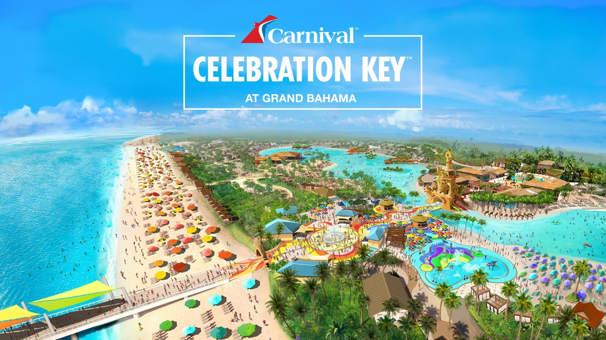

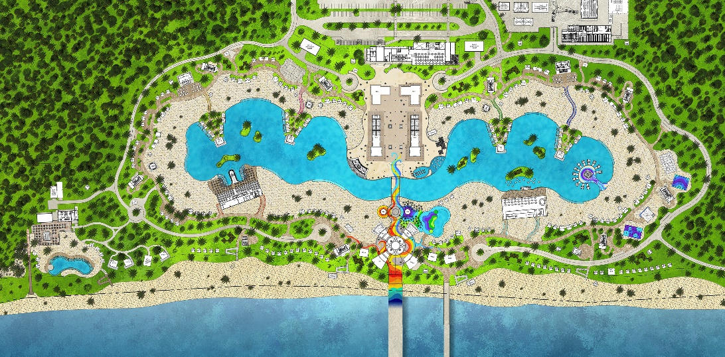

B. BACKGROUND & PROJECT LOCATION

- Carnival Corporation & plc and Carnival Cruise Line

Carnival Corporation & plc, the world’s largest leisure travel company, provides travelers around the globe with extraordinary vacations at an exceptional value. The company’s portfolio of global cruise line brands includes nine (9) distinct brands operating worldwide. Together, these brands comprise the world’s largest cruise company with a fleet of over 90 ships visiting more than 700 ports around the world. For more information, please visit http://www.carnivalcorporation.com/.

The Destination is being designed primarily to serve Carnival Cruise Line. Carnival Cruise Line is “The World’s Most Popular Cruise Line” and currently operates 25 ships on three to 24-day voyages worldwide. One new ship is scheduled for delivery – Carnival Jubilee in late 2023 – and one ship is scheduled to be transferred in – Carnival Firenze in 2024. For more information, please visit http://www.carnival.com.

- Project Location

The Destination is located on the south shore of Grand Bahama Island on approximately 329 acres of beachfront land (the “Site”, see Exhibit B), in the area known as Sharp Rock. Carnival is conserving a significant portion of the acreage as wetlands. Approximately forty (40) acres of land is being utilized for Celebration Key.

C. PROJECT DESCRIPTION

- Objective

Celebration Key is a dedicated cruise ship destination designed to accommodate two cruise ships per day, with a daily onshore capacity of up to 13,000 guests and 4,000 crew members. We expect 2M+ passengers annually, and we expect to have ship calls almost every day of the year, including holidays.

The port destination opened July 19, 2025.

This is the 3rd round of the Food Truck RFP and we are interest in finding one more Operator to provide Food & Beverage at the Destination, Carnival plans to negotiate and execute a commercial agreements with a qualified Bahamian Operator. The commercial agreement(s) will ask for the Operator(s) to participate in design, build, full operation and maintenance of F&B Operations at the Destination. Operators are being invited to provide qualifications for consideration for specific F&B Operations.

For more information please visit https://www.CelebrationKeyPort.com/ and follow us on Social Media:
- Instagram: https://www.instagram.com/celebrationkeygrandbahama/
- Facebook: https://www.facebook.com/people/Celebration-Key-Grand-Bahama/61552410317019/

- Extent and Scope of the Project

Overall F&B Operations at the Destination will be designed to provide daily food and beverage for several thousand guests and crew across a variety of daily operational scenarios. The Destination will primarily receive ships during the day (8 a.m. to 5 p.m.), although night operations may be needed.

The scope of this RFP includes the below:

One (1) Food Truck / Food Trailer (guest area):
  - Operate a fully functional food truck within the designated area of Starfish Lagoon
  - Bahamian inspired menu, tailored to North American guests’ taste, preferred.
  - Ensure food safety, cleanliness, and compliance with local health regulations.
  - Use eco-friendly packaging and sustainable practices where possible.
  - Collaborate with Celebration Key’s operations team to align with brand and guest experience standards.

Interested parties should note that:
- Only Bahamian owned and operated businesses qualify.
- All Look & Feel guidance will be provided by Carnival (including potential outlet names).
- Design, construction, operations and maintenance shall comply with applicable requirements of the Americans with Disability Act and Carnival Corporation’s Rules, Regulations.
- All operators will be required to adhere to strict Public Health Guidelines.
- Each operator will be required to follow Carnival’s Health, Safety and Environmental strict requirements, which will be audited frequently.

Guests/ Crew will be charged directly by the Operator for all purchases, via credit card and cash.

Existing Bahamian brands, or brands uniquely created for the Destination, are preferred.

- Evaluation Criteria
Proposals will be evaluated based on:
- Bahamian-owned and operated.
- Currently operating or ready to operate a food truck or trailer.
- Hold a valid business license (or willing to obtain the GBPA license) and any required permits (e.g., GBPA)
- Ability to follow local health and safety regulations.
- Ability to meet project timeline.

- Proposed Project Schedule:

For this Request for Proposal, Carnival has established the following timeline for the completion of the RFP process. Potential Operators not responding by these due dates may be disqualified:

Sourcing Process | Due Date
Request for Proposal Posted on the Website - | 9/23/2025
Operator Questions Due to Carnival | 9/29/2025
Carnival Answers to Operators | 10/03/2025
RFP Responses Due | 10/13/2025
Carnival RFP Review and Evaluation | By 10/18/2025
Operator Presentations (if asked for by Carnival) | Week of 10/20/2025
Preferred Operator(s) selected | 10/30/2025
Business Award Notification sent | 11/05/2025
Finalize Leasing Agreements | 11/13/2025

- REQUIRED SUBMITTALS

RFP responses should be submitted by close of business on September 29, 2025. Interested Operators are requested to submit their information, which must include and reference the elements included in the RFP Response Outline (Exhibit A), via email to eclaxton@carnival.com and Ckconcessionaire@carnival.com. All information provided will be held confidentially by Carnival.

EXHIBIT A: ATTACHMENT 1

Please complete the below questionnaire. No handwritten response will be accepted.

Submit any questions you may have before September 29 to via email to eclaxton@carnival.com.

As stated in the timeline of the RFP, responses are due no later than October 13, 2025.

 | Company name
 | Contact Name
 | Contact Phone Number
 | Contact Email Address
 |  | Response Date :
1. Food Truck RFP
# | Questions | Response
1 | Are you a Bahamian owned and operated company?
2 | Include a brief company history, especially in the food and beverage sector.
3 | Describe your experience operating food trucks, restaurant or similar ventures.
4 | Provide examples of successful operations, particularly in high-traffic tourist areas.
5 | How does your company ensure compliance with local health, environmental, and safety regulations?
6 | Provide details of any certifications, training, or audits your company has undergone.
7 | Describe the food concept(s) you propose, include full description and pictures.
8 | What makes your menu/ concept “Bahamian inspired”, or how would you tailor your menu/ concept to be more aligned with the Vision?
9 | Will you be able to operate the food truck everyday (7 days a week)?
10 | How will you manage inventory, waste, and customer flow?
11 | Describe your approach to minimizing environmental impact, including packaging and waste management practices.
12 | Does the company have proper licenses (government, GBPA)? If existing, please indicate where you currently operate, under what name and for how long ? Please provide details.
13 | Do you have business liability insurance? If so, what's the coverage? If not, are you willing to purchase a policy to do business with Carnival?
14 | What is your pricing strategy, and how do you plan to keep your products competitively priced for tourists
15 | Provide at least two references from similar operations, including contact details.
1.2 Additional Attachments Area
End of RFP

