Carnival Grand Bahama Investments Limited
CELEBRATION KEY

Request for Proposal (RFP) for
Professional Hair Braiders
at Celebration Key at Grand Bahama

September 2025

I. GENERAL

A. INTRODUCTION

Carnival Corporation & plc via its subsidiary Carnival Grand Bahama Investments Limited (“Carnival”) is requesting proposals from businesses or individuals (“Operators”) interested in providing professional hair braiding services at Celebration Key by Carnival at Sharp Rock on Grand Bahama Island (“the Destination”), approximately thirteen (13) miles from downtown Freeport.

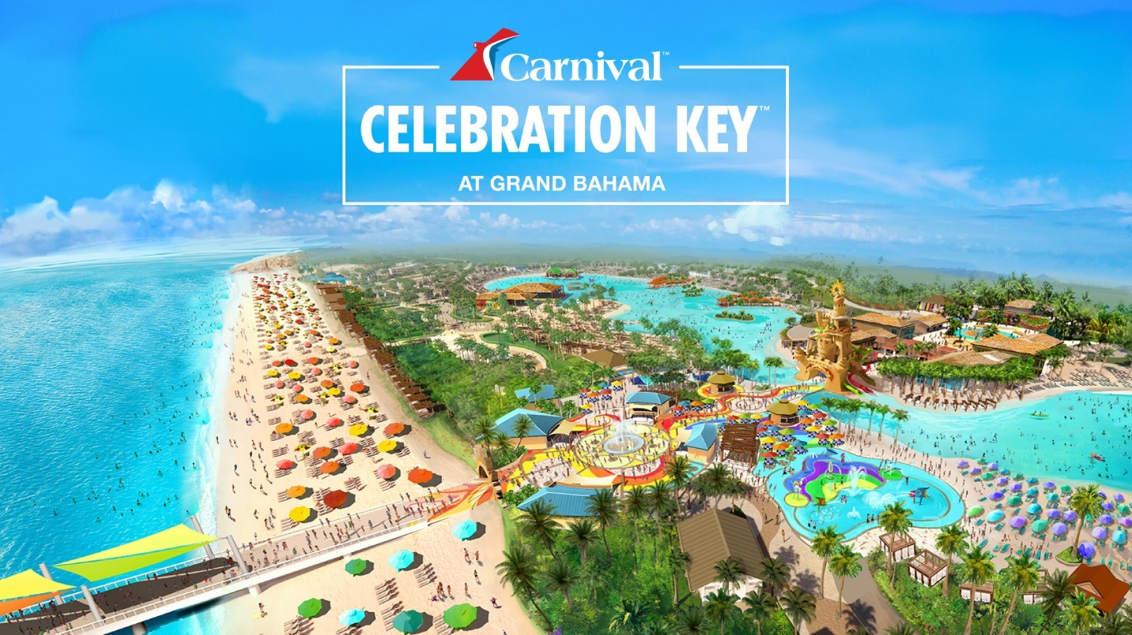

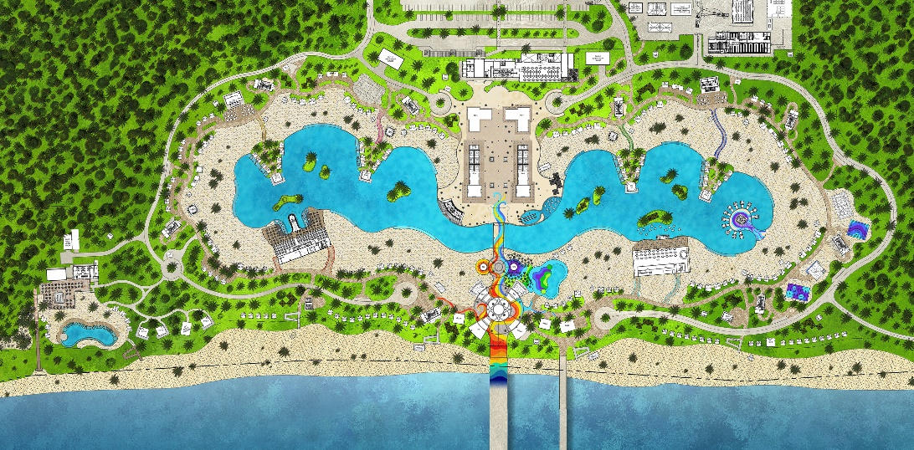

B. BACKGROUND & PROJECT LOCATION

- Carnival Corporation & plc and Carnival Cruise Line

Carnival Corporation & plc, the world’s largest leisure travel company, provides travelers around the globe with extraordinary vacations at an exceptional value. The company’s portfolio of global cruise line brands includes nine (9) distinct brands operating worldwide. Together, these brands comprise the world’s largest cruise company with a fleet of over 90 ships visiting more than 700 ports around the world. For more information, please visit http://www.carnivalcorporation.com/.

The Destination is being designed primarily to serve Carnival Cruise Line. Carnival Cruise Line is “The World’s Most Popular Cruise Line” and currently operates 25 ships on three to 24-day voyages worldwide. For more information, please visit http://www.carnival.com.

- Project Location

The Destination is located on the south shore of Grand Bahama Island on approximately 329 acres of beachfront land (the “Site”, see Exhibit B), in the area known as Sharp Rock. Carnival is conserving a significant portion of the acreage as wetlands. Approximately forty (40) acres of land is being utilized for Celebration Key.

C. PROJECT DESCRIPTION

- Objective

Celebration Key is a dedicated cruise ship destination designed to accommodate two cruise ships per day, with a daily onshore capacity of up to 13,000 guests and 4,000 crew members. We expect 2M+ passengers annually, and we expect to have ship calls almost every day of the year, including holidays.

The port destination opened July 19, 2025.

This RFP is for professional hair braiding services at the Destination. Carnival plans to negotiate and execute a commercial agreement with a qualified Bahamian Hair Braider. The commercial agreement(s) will ask for the Operator(s) to participate in setup, full operation, the kiosk upkeep (cleanliness) and hair braiding service at the Destination.

For more information please visit https://www.CelebrationKeyPort.com/ and follow us on Social Media:
- Instagram: https://www.instagram.com/celebrationkeygrandbahama/
- Facebook: https://www.facebook.com/people/Celebration-Key-Grand-Bahama/61552410317019/

- Extent and Scope of the Project

Hair braiding services will be available to several thousand guests and crew across a variety of daily operational scenarios. The Destination will primarily receive ships during the day (8 a.m. to 5 p.m.), although night operations may be needed.

The scope of this RFP includes:
- Operate a professional hair braiding kiosk within the designated area of Celebration Key.
- To ensure many guests can experience hair braiding services, all services will be provided in 30 minutes or less
- Maintain a clean and hygienic work area.
- Ensure compliance with local health regulations.
- Collaborate with Celebration Key’s operations team to align with brand and guest experience standards.

Interested parties should note:
- Only Bahamian owned and operated businesses qualify.
- Setup, operations and kiosk maintenance shall comply with applicable requirements of Carnival Corporation’s Rules and Regulations.
- All operators will be required to adhere to strict Public Health Guidelines.
- Celebration Key is open every day, so there will be several hair braiders selected to operate rotationally, which may result in kiosks being shared.
- Each operator will be required to follow Carnival’s Health, Safety and Environmental strict requirements, which will be audited frequently.

Guests will be charged directly by the Operator for all purchases, via credit card and cash.

- Evaluation Criteria

Proposals will be evaluated based on:
- Bahamian-owned and operated
- Currently operating or ready to operate a Hair braiding service kiosk
- Experience and picture of previous clients
- Hold a valid business license (or willing to obtain the GBPA license) and beautician / cosmetology license required
- Ability to comply with local health and safety regulations
- Ability to start immediately after selection.

- Proposed Project Schedule:

For this Request for Proposal, Carnival has established the following timeline for the completion of the RFP process. Potential Operators not responding by these due dates may be disqualified:

Sourcing Process | Due Date
Request for Proposal Posted on the Website - | 9/23/2025
Operator Questions Due to Carnival | 9/29/2025
Carnival Answers to Operators | 10/03/2025
RFP Responses Due | 10/13/2025
Carnival RFP Review and Evaluation | By 10/16/2025
Operator Presentations (if asked for by Carnival) | 10/20- 10/22/2025
Preferred Operator(s) selected | 10/24/2025
Business Award Notification sent | 10/27/2025
Finalize Leasing Agreements | 11/07/2025

- REQUIRED SUBMITTALS

Information is to be submitted by close of business on October 13, 2025. Interested Operators are requested to submit their information, which must include and reference the elements included in the RFP Response Outline (Exhibit A), via upload to our webpage: https://www.CelebrationKeyPort.com/ and via email to eclaxton@carnival.com and Ckconcessionaire@carnival.com

Any questions or issues with uploading should be addressed via e-mail to F&B@carnivalgrandport.com. All information provided will be held confidentially by Carnival.

EXHIBIT A: ATTACHMENT 1

Please complete the below questionnaire. No handwritten response will be accepted.

Submit any questions you may have before September 29.

As stated in the timeline of the RFP, responses are due no later than October 13, 2025.

 | Company name
 | Contact Name
 | Contact Phone Number
 | Contact Email Address
 |  | Response Date :
1. Food Carts
# | Questions | Response
1 | Are you a Bahamian owned and operated company?
2 | How many years of experience do you have in hair braiding?
3 | Do you hold a valid beautician license or cosmetology certification? (Attach a copy)
4 | Do you have a valid business license? (Attach a copy) Or willing to apply for a business license?
5 | Please provide references and examples of previous work. (attach pictures)
6 | How do you ensure cleanliness and hygiene in your work area?
7 | What hair products and accessories do you use to execute your hair braiding?
8 | Are you available to begin services immediately upon selection?
9 | Provide a proposed service and price list of hair braiding that will be completed in 15 minutes or less.
1.2 Additional Attachments Area
End of RFP

